BEST PRACTICE PROGRAMME

for Local Government in Bulgaria
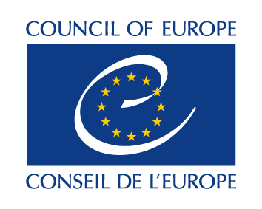

APPLICATION FORM

Please submit the Application Form before
February 15, 2017!

I. GENERAL INFORMATION

A) Name of Municipality: __________________________
B) Size: Population (number of residents) ____________ Territory (km²) ____________
C) Number of employees in the municipality: __________________________________

D) Contact person with reference to the practice presented:
Name: __________________________________ Position:________________________________
Tel.:____________________________________ E-mail: ____________________
E) The theme in which the good practice is being presented (select one area):
- Municipal support for civic initiatives
- New management technologies and solutions
- Social innovation and partnerships
II. DESCRIPTION OF PRACTICE

1. Name of the practice

2. Month and year in which the practice was implemented

3. Summary of the practice (Please, describe with up to 100 words)

4. Please describe the problem addressed by the practice (Please, describe with up to 500 words):
What is the problem you intended to solve through this practice? When did the problem occur and what caused its appearance? How many people were affected by this problem? What would be the consequences of this problem for the community, had it not been resolved by implementing the practice? (for example: financial losses)

To achieve what purpose of the municipality the described practice contributes?

5. Please describe the practice (Please, describe with up to 1500 words):
Describe briefly how the practice emerged. What are the activities undertaken under the practice? What are the activities undertaken in connection with the practice? Who were the participants in the planning and implementation of practice (eg NGOs, business, media)?

6. What are the qualitative changes / results from the implementation of practices at the community level (Please, describe with up to 800 words):
What are the benefits / results at the community level? - All quantitative indicators, numbers or statistics are welcome)

7. Financial dimensions of practice:
What were the costs of this practice? Has there been contribution to the municipal spending? What share of the costs was co-financed by external actors?

8. Evidence of the benefits / successes of practice (Please, describe with up to 500 words):
Why do you think the practice is relevant? Why do you think the practice is open and transparent? Why do you think the practice is innovative? Why do you think the practice is sustainable? The candidates are welcomed to attach one or two photos, posts and / or video if they believe that this may help to explain the practice or its impact on the community.

9. Can this experience be useful for other communities / local authorities in Bulgaria and why or how? (Please, describe with up to 200 words):

Hereby, I confirm that the information in this application form is correct.

Mayor:: | Signature:

For additional questions, please contact:
Rossitsa Raycheva, FLGR
Tel..: 02 976 89 89
rraycheva@flgr.bg

